January 23, 2014

Dear Partners in Caring participants:

We look forward to your participation in the Partner’s in Caring: A Faith Leaders Seminar on Wednesday, February 5, 2014.

Memorial Hospital is at 1325 Cottonwood St, Any town, California. The hospital is at the corner of Cottonwood and West Gibson St. Parking is available in front of the hospital and at the Advanced Imaging and Surgery Center, at 1321 Cottonwood St, just north of the hospital.

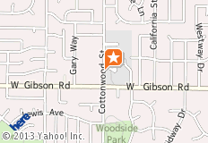

We will meet in the Dining Conference Room on the 1st floor, just behind the cafeteria. Please join us at 8:00 am for registration and a light breakfast. Our program will begin at 8:30 am.

In preparation for the day, we are enclosing an article for you to read. We also ask that you complete the Life Activities form and bring it with you, as it will be used during an activity. In addition, please review and reflect on the Personal Priorities & Spiritual Values form, as well as the Personal Reflection survey.

If you have completed an Advance Health Care Directive (AHCD), please feel free to bring it with you. We will also include an AHCD in your Partners in Caring binder.

We are excited about the special seminar and look forward to spending the day with you. Please call XXX-XXX-XXXX if you have any questions.

Sincerely,

Jane Doe, FNP Bob Smith, Chaplain

